GIT Challenges

Resolve Merge Conflicts

Step 1: Create a repository
mkdir merge-conflict-demo
cd merge-conflict-demo

git init

echo "Welcome to Git" > demo.txt

git add .
git commit -m "Initial commit"

Step 2: Create Branch A
git checkout -b feature1
Edit
demo.txt
Change
Welcome to Git
to
Welcome to Git from Feature1
Commit
git add .
git commit -m "Updated from feature1"

Step 3: Create Branch B
Go back
git checkout main
git checkout -b feature2
Edit the same line
Welcome to Git from Feature2
Commit
git add .
git commit -m "Updated from feature2"

Step 4: Merge
git checkout main

git merge feature1

git merge feature2
Git shows
CONFLICT (content): Merge conflict in demo.txt
Open file
<<<<<<< HEAD
Welcome to Git from Feature1
=======
Welcome to Git from Feature2
>>>>>>> feature2

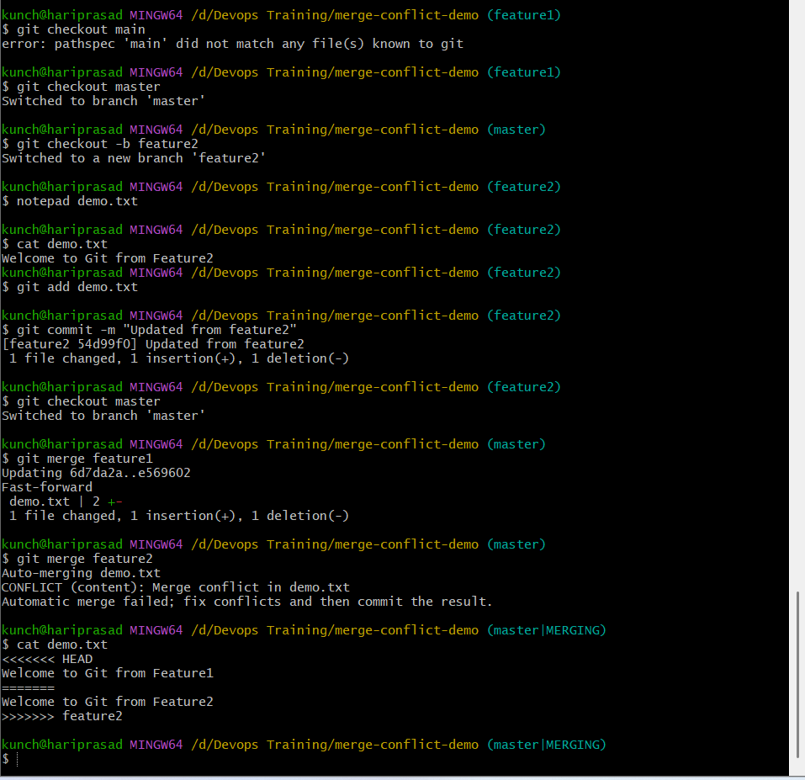
Resolve
Welcome to Git from Feature1 and Feature2
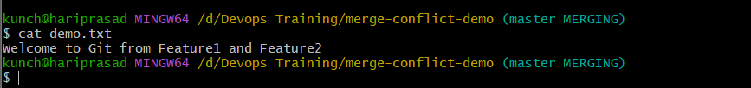
Save
git add demo.txt

git commit -m "Resolved merge conflict"

git push origin main

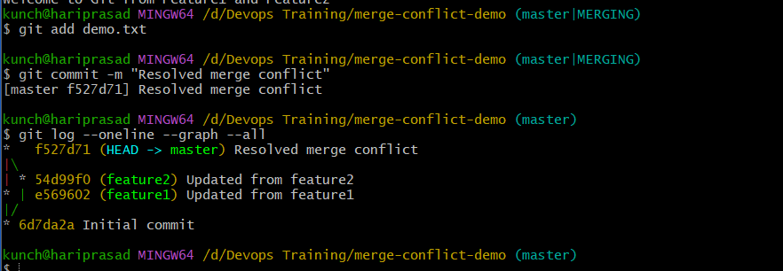

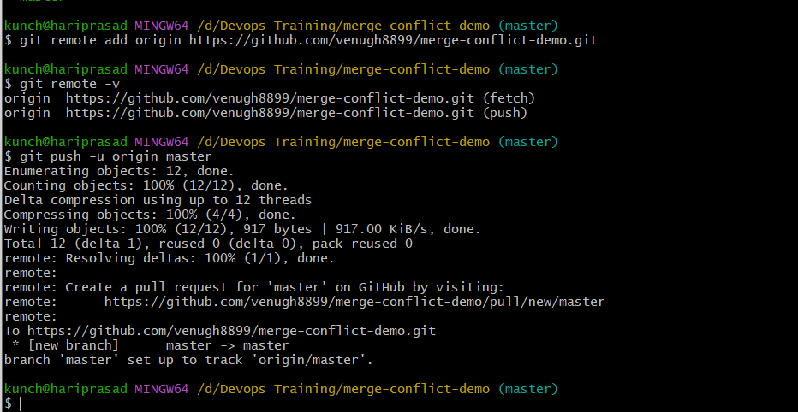

2. Recover Deleted Branch
Step 1: Check your current branch
git branch
Expected:
feature1
feature2
* master

Step 2: Create a new branch
git checkout -b testing
Expected:
Switched to a new branch 'testing'
Verify:
git branch
Output:
feature1
feature2
master
* testing

Step 3: Create a new file
echo "This file is created in testing branch." > test.txt
Check:
cat test.txt
Output:
This file is created in testing branch.

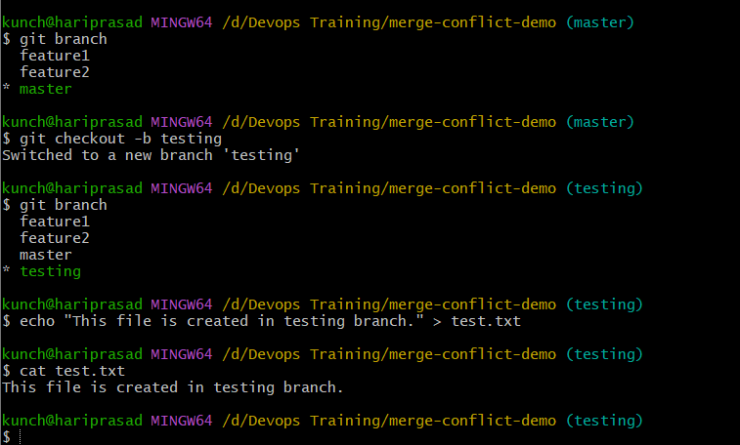

Step 4: Check the status
git status
Expected:
Untracked files:
test.txt

Step 5: Stage the file
git add test.txt

Step 6: Commit the file
git commit -m "Added test.txt in testing branch"
Expected:
[testing xxxxxxx] Added test.txt in testing branch

Step 7: View the commit history
git log --oneline --graph --all
You should see something like:
* abc1234 (HEAD -> testing) Added test.txt in testing branch
* f527d71 (master, origin/master) Resolved merge conflict
|\
| * 54d99f0 (feature2) Updated from feature2
* | e569602 (feature1) Updated from feature1
|/
* 6d7da2a Initial commit
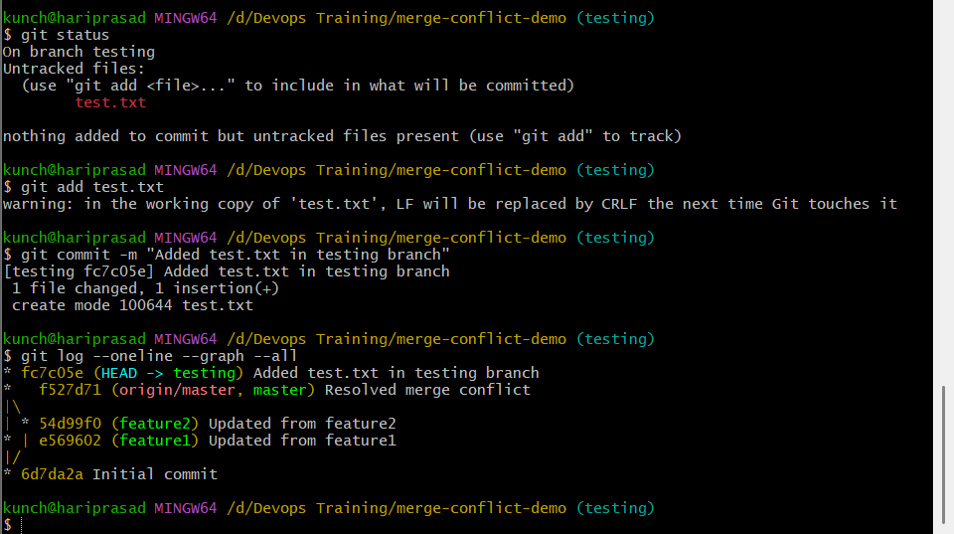

Step 8: Switch back to master
git checkout master

Step 9: Delete the branch
We're intentionally deleting the branch to recover it later.
git branch -D testing
Expected:
Deleted branch testing (was abc1234).

Step 10: Confirm the branch is gone
git branch
Output:
feature1
feature2
* master
Notice that testing is no longer listed.

Step 11: Recover the deleted branch using git reflog
Run:
git reflog
You will see output similar to:
abc1234 HEAD@{0}: checkout: moving from testing to master
abc1234 HEAD@{1}: commit: Added test.txt in testing branch
f527d71 HEAD@{2}: checkout: moving from master to testing
...
The important commit is:
abc1234 HEAD@{1}: commit: Added test.txt in testing branch
Copy the commit hash (abc1234 in this example).
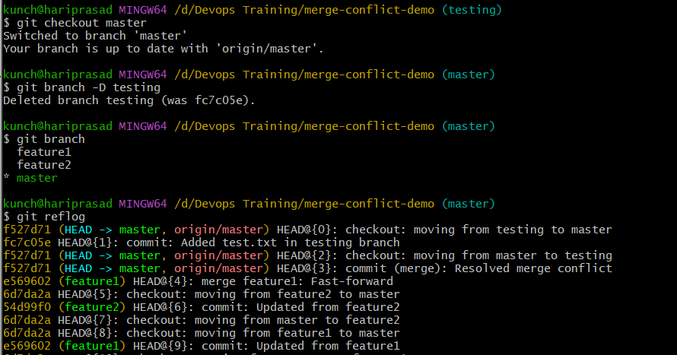

Step 12: Recreate the deleted branch
Replace abc1234 with your actual commit hash:
git checkout -b testing abc1234
Expected:
Switched to a new branch 'testing'

Step 13: Verify
git branch
Output:
feature1
feature2
master
* testing
Also verify the file:
ls
Output:
demo.txt
test.txt
The deleted branch has been successfully recovered.

Step 14 (Optional): Push the recovered branch to GitHub
git push -u origin testing
Expected:
branch 'testing' set up to track 'origin/testing'.

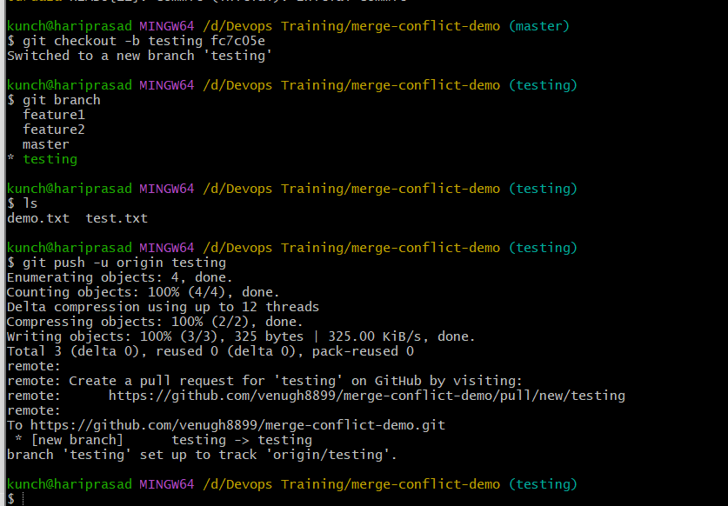

3. Undo Wrong Push
Make wrong commit
echo "Wrong code" >> app.txt

git add .
git commit -m "Wrong commit"

git push
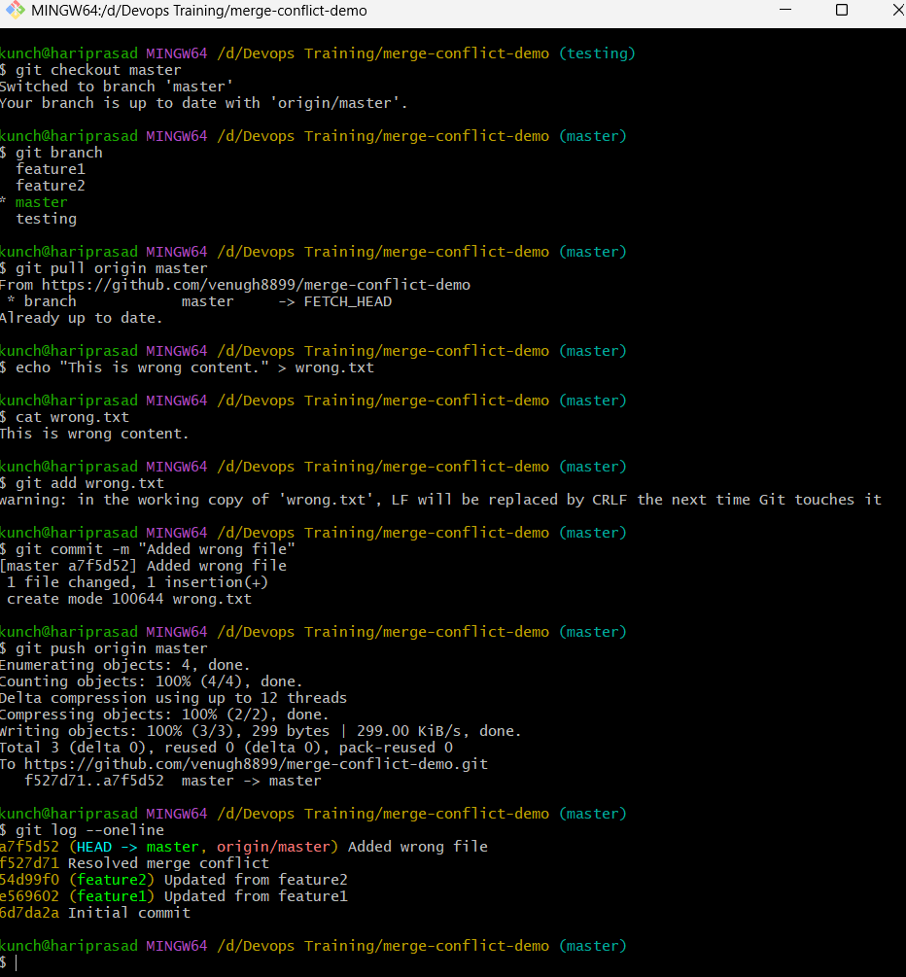

Undo without changing history
git revert HEAD

git push
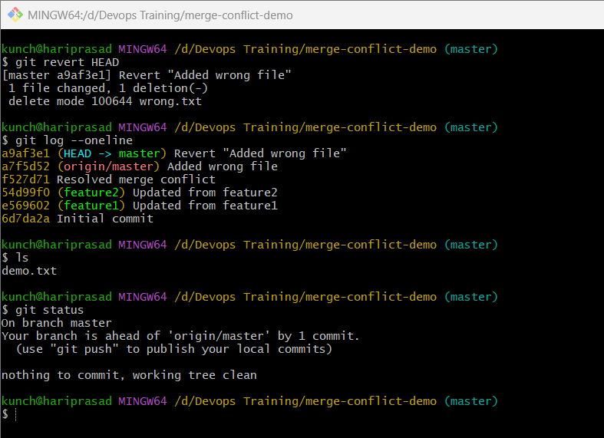
History becomes
Wrong commit

Revert "Wrong commit"

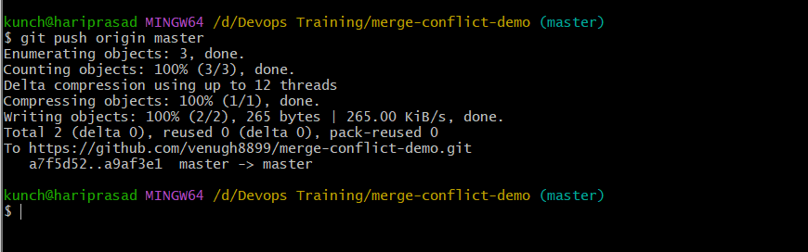

4. Amend a Commit
Step 1: Ensure you're on master
git checkout master

Step 2: Create the first file
echo "Employee Details" > employee.txt
Check:
cat employee.txt
Output:
Employee Details

Step 3: Stage the file
git add employee.txt

Step 4: Commit it
git commit -m "Added employee details"
Example:
[master 8d1f23a] Added employee details

Step 5: Oops! You forgot another file

Create another file:
echo "Department Details" > department.txt
Verify:
cat department.txt
Output:
Department Details
At this point:
git status
Expected:
Untracked files:
department.txt
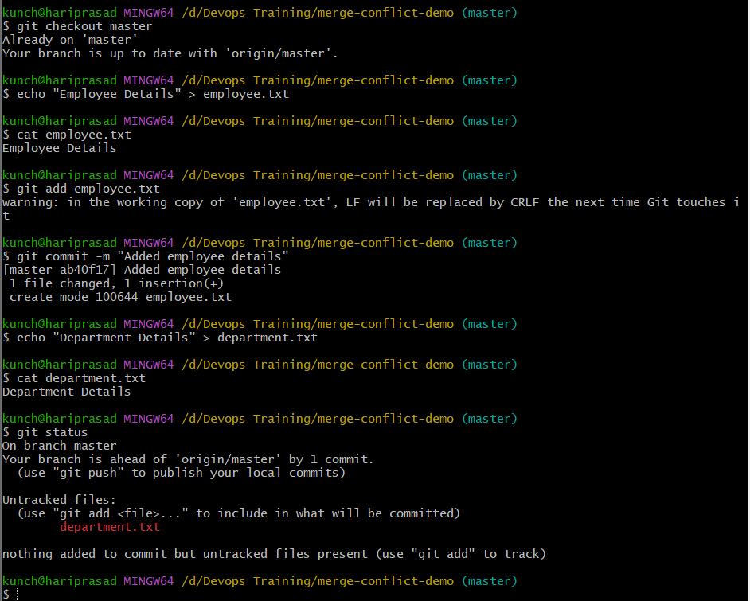

Step 6: Stage the forgotten file
git add department.txt

Step 7: Amend the previous commit
git commit --amend
Git will open your default editor.
You'll see the previous commit message:
Added employee details
You can:
- Keep the same message, or
- Change it to something better, such as:
Added employee and department details
Save and close the editor.
Alternative (recommended)
If you want to change the commit message directly from the command line:
git commit --amend -m "Added employee and department details"

Step 8: Verify the history
git log --oneline
You'll see only one new commit, for example:
9ab45cd Added employee and department details
Notice there isn't a second commit for department.txt.

Step 9: Verify both files are included
git show --stat HEAD
Expected output:
employee.txt
department.txt
Both files are now part of the same commit.
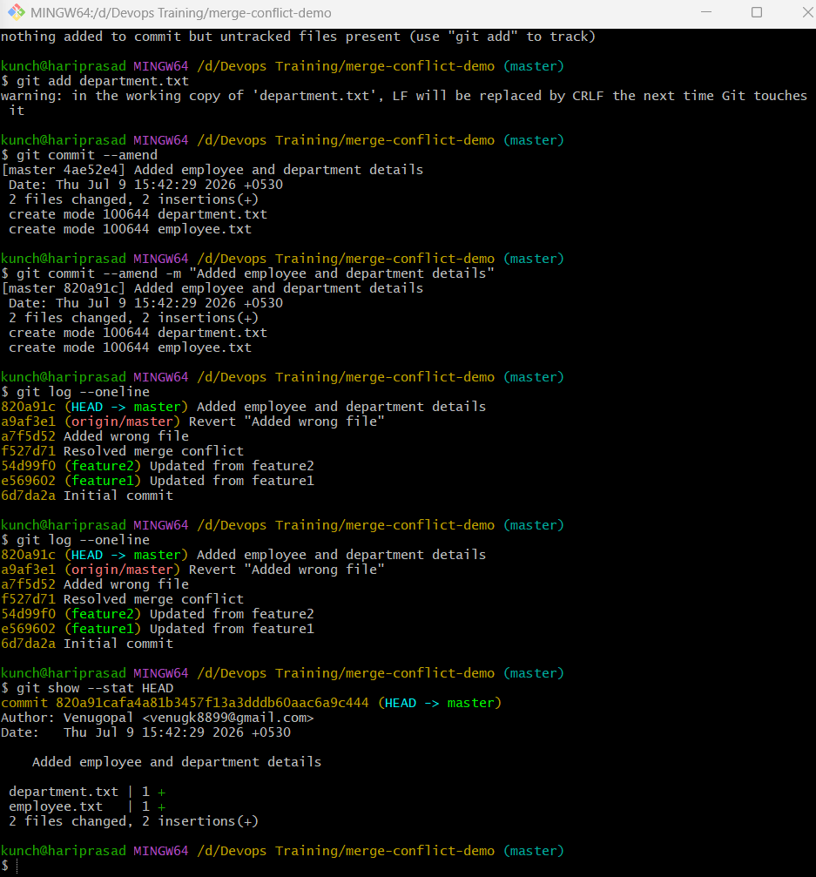

Step 10: Push to GitHub (if the commit has not been pushed before)
git push origin master
If you had already pushed the original commit before amending it, Git would reject the push because the commit ID changed. In that case, you'd need:
git push --force-with-lease origin master
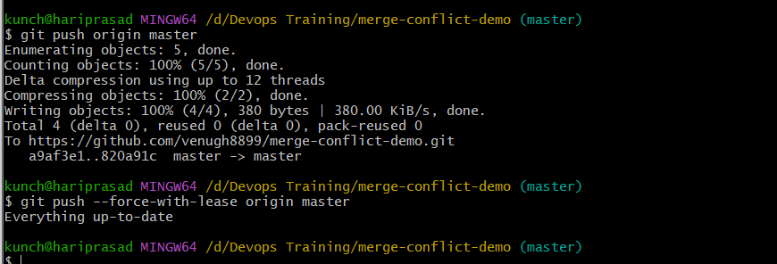

5. Cherry-pick a Commit

Step 1: Check your current branch

git branch

Expected:

feature1

feature2

testing

* master

Step 2: Create a new branch

git checkout -b feature-login

Expected:

Switched to a new branch 'feature-login'

Step 3: Create a file

echo "Login functionality" > login.txt

Verify:

cat login.txt

Output:

Login functionality

Step 4: Stage the file

git add login.txt

Step 5: Commit

git commit -m "Added login feature"

Example:

[feature-login a1b2c3d] Added login feature

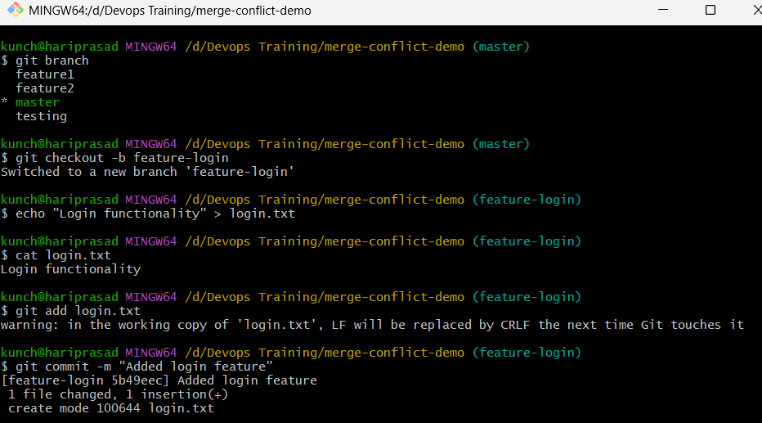

Step 6: Create another file

echo "Logout functionality" > logout.txt

Stage it:

git add logout.txt

Commit it:

git commit -m "Added logout feature"

Now the branch has two commits.

Step 7: View commit history

git log --oneline

Example:

5f7d8e9 Added logout feature

a1b2c3d Added login feature

Copy the commit ID for Added login feature (for example, a1b2c3d).

Step 8: Switch back to master

git checkout master

Step 9: Cherry-pick the commit

Replace a1b2c3d with your actual commit ID:

git cherry-pick a1b2c3d

Expected:

[master c4d5e6f] Added login feature

Git copies only that commit to master.

Step 10: Verify

git log --oneline --graph --all

You should see something similar to:

* 5f7d8e9 (feature-login) Added logout feature

* a1b2c3d Added login feature

| * c4d5e6f (HEAD -> master) Added login feature

|/

* previous commits...

Notice:
- master has Added login feature.
- master does not have Added logout feature.

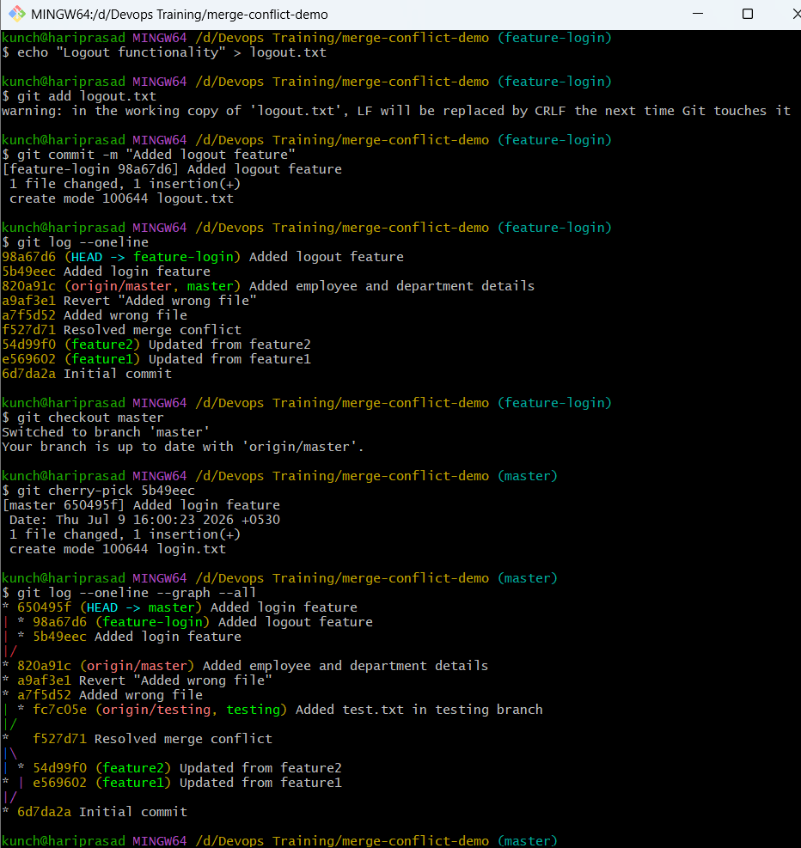

Step 11: Verify the files

On master:

ls

Expected:

demo.txt

employee.txt

department.txt

login.txt

logout.txt should not be present.

Step 12: Push to GitHub

git push origin master

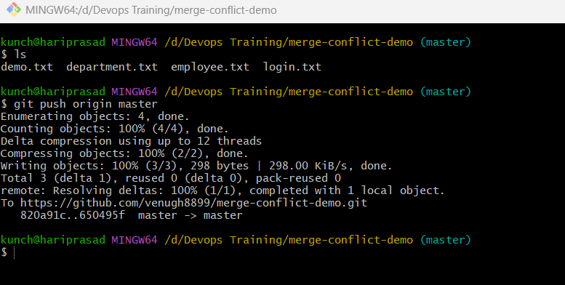

6. Interactive Rebase
Step 1: Create a practice branch
git checkout master
git checkout -b rebase-demo
Verify:
git branch
Expected:
feature-login
feature1
feature2
master
testing
* rebase-demo

Step 2: Create Commit 1
echo "Line 1" > rebase.txt

git add rebase.txt

git commit -m "Added line 1"

Step 3: Create Commit 2
echo "Line 2" >> rebase.txt

git add rebase.txt

git commit -m "Added line 2"

Step 4: Create Commit 3
echo "Line 3" >> rebase.txt

git add rebase.txt

git commit -m "Added line 3"

Step 5: Check the history
git log --oneline
Example:
8c3f741 Added line 3
2f7b92d Added line 2
d41f652 Added line 1
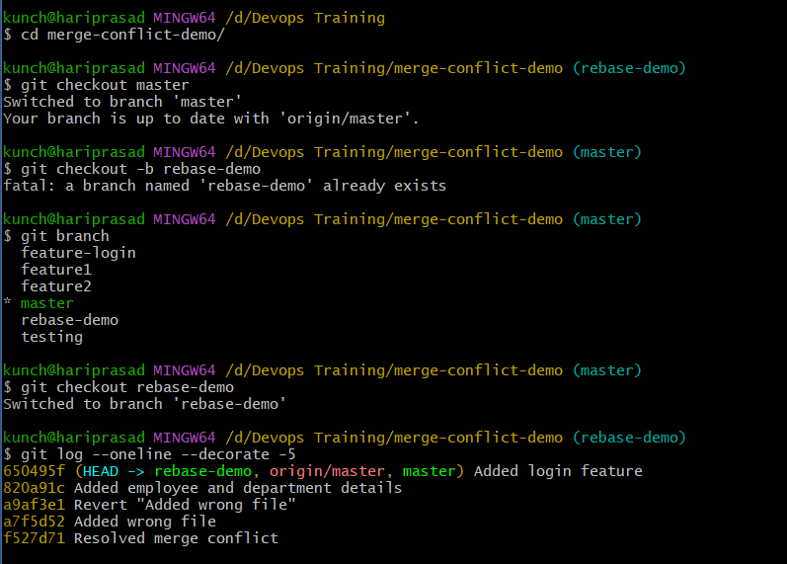

Step 6: Start Interactive Rebase

git rebase -i HEAD~3
The editor will show:
pick ghi9012 Added line 1
pick def5678 Added line 2
pick abc1234 Added line 3
Change it to:
pick ghi9012 Added line 1
squash def5678 Added line 2
squash abc1234 Added line 3
Save and exit.

Step 7: Edit the commit message
Git opens another editor. Replace everything with:
Added rebase demo file
Save and exit.

Step 8: Verify
git log --oneline -3
Now you'll see only one commit:
xyz7890 Added rebase demo file
And verify the file:
cat rebase.txt
Output:
Line 1
Line 2
Line 3

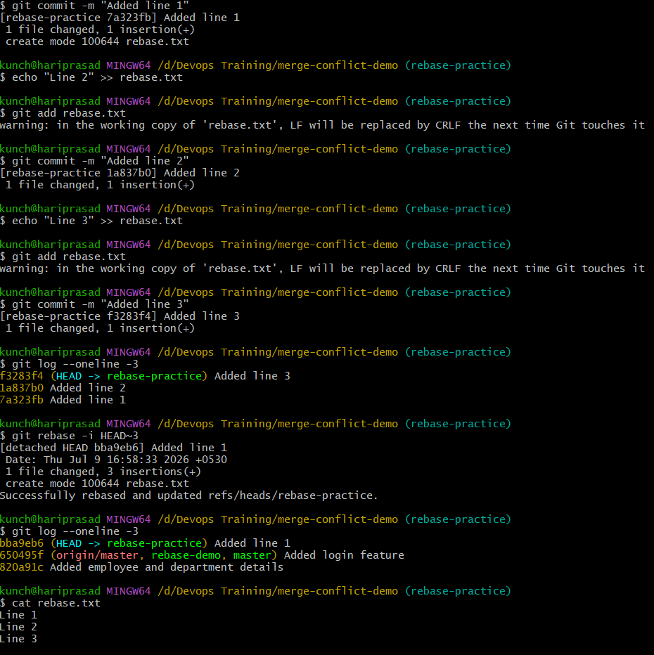

Step 7: Squash Commits
Change it to:
pick d41f652 Added line 1
squash 2f7b92d Added line 2
squash 8c3f741 Added line 3
or simply:
pick d41f652 Added line 1
s 2f7b92d Added line 2
s 8c3f741 Added line 3
Save and close the editor.

Step 8: Edit the Commit Message
Git opens another editor showing:
# This is a combination of 3 commits.

Added line 1

Added line 2

Added line 3
Replace everything with:
Added rebase demo file
Save and close.

Step 9: Verify the History
git log --oneline
Expected:
5ab9123 Added rebase demo file
Only one commit remains instead of three.

Step 10: Verify the File
cat rebase.txt
Output:
Line 1
Line 2
Line 3

7. Tagging & Release
Objective
Learn how to:
- Create a tag (v1.0)
- Push the tag to GitHub
- View tags
- Delete a local tag
- Delete a remote tag
- Restore the tag
- Push it again

What is a Tag?
A tag is a reference to a specific commit, commonly used to mark software releases.
Example:
v1.0 → First Release
v1.1 → Bug Fix Release
v2.0 → Major Release
Unlike branches, tags don't move when new commits are added.

Step 1: Go to the master branch
git checkout master
Expected:
Switched to branch 'master'
Your branch is up to date with 'origin/master'.

Step 2: Verify the latest commit
git log --oneline -3
Example:
650495f Added login feature
820a91c Added employee and department details
a9af3e1 Revert "Added wrong file"
We'll tag the current HEAD.

Step 3: Create an annotated tag
git tag -a v1.0 -m "Version 1.0 Release"
Here:
- -a → Annotated tag
- v1.0 → Tag name
- -m → Tag message

Step 4: Verify the tag
List all tags:
git tag
Expected:
v1.0
View details:
git show v1.0
You'll see:
tag v1.0
Tagger: Your Name
Date: ...

Version 1.0 Release

commit 650495f...
Author: ...

Step 5: Push the tag to GitHub
git push origin v1.0
Expected:
To https://github.com/venugh8899/merge-conflict-demo.git
* [new tag] v1.0 -> v1.0

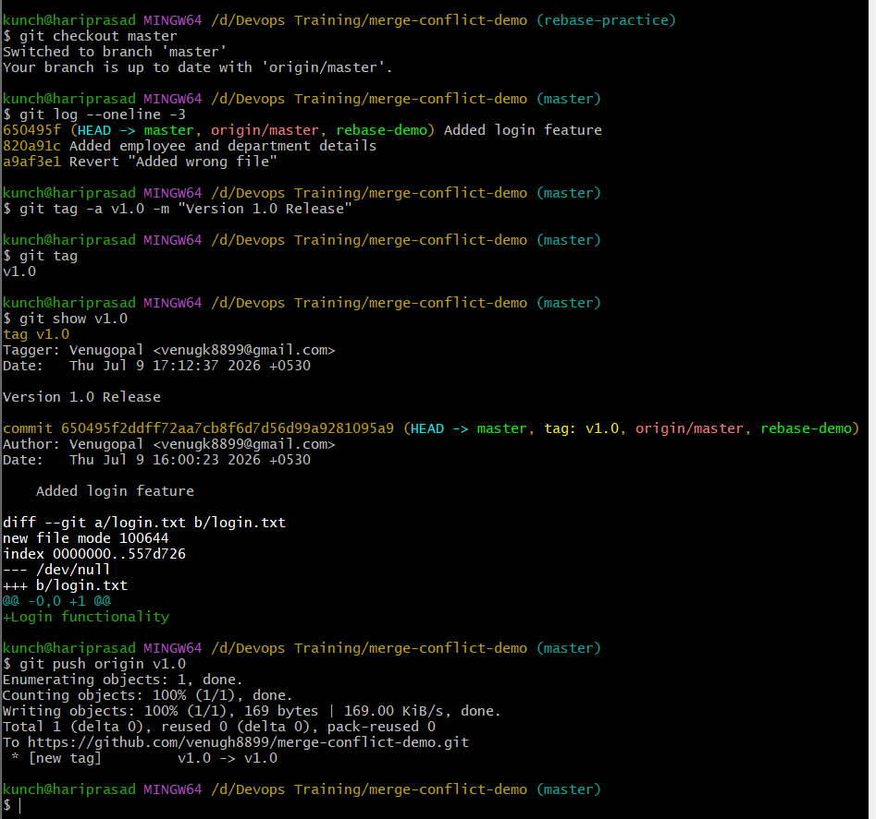

Step 6: Verify on GitHub
Open:
https://github.com/venugh8899/merge-conflict-demo
Click:
Releases → Tags
or
Tags
You should see:
v1.0
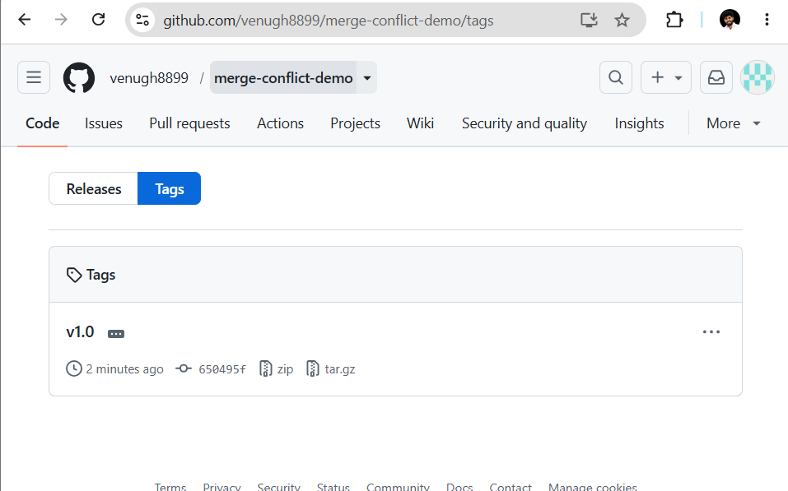

Step 7: Delete the local tag
git tag -d v1.0
Expected:
Deleted tag 'v1.0'
Verify:
git tag
No output means the local tag is gone.

Step 8: Delete the remote tag
git push origin --delete v1.0
Expected:
To https://github.com/venugh8899/merge-conflict-demo.git
- [deleted] v1.0
Verify on GitHub that the tag has been removed.

Step 9: Restore the tag locally
Create it again on the current commit:
git tag -a v1.0 -m "Version 1.0 Release"
Verify:
git tag
Output:
v1.0

Step 10: Push the restored tag
git push origin v1.0
Expected:
To https://github.com/venugh8899/merge-conflict-demo.git
* [new tag] v1.0 -> v1.0

Step 11: Verify everything
Branches:
git branch
Tags:
git tag
Commit history:
git log --oneline --decorate
Example:
650495f (HEAD -> master, tag: v1.0, origin/master) Added login feature
820a91c Added employee and department details
a9af3e1 Revert "Added wrong file"
Notice:
tag: v1.0
This indicates that the tag points to that commit.
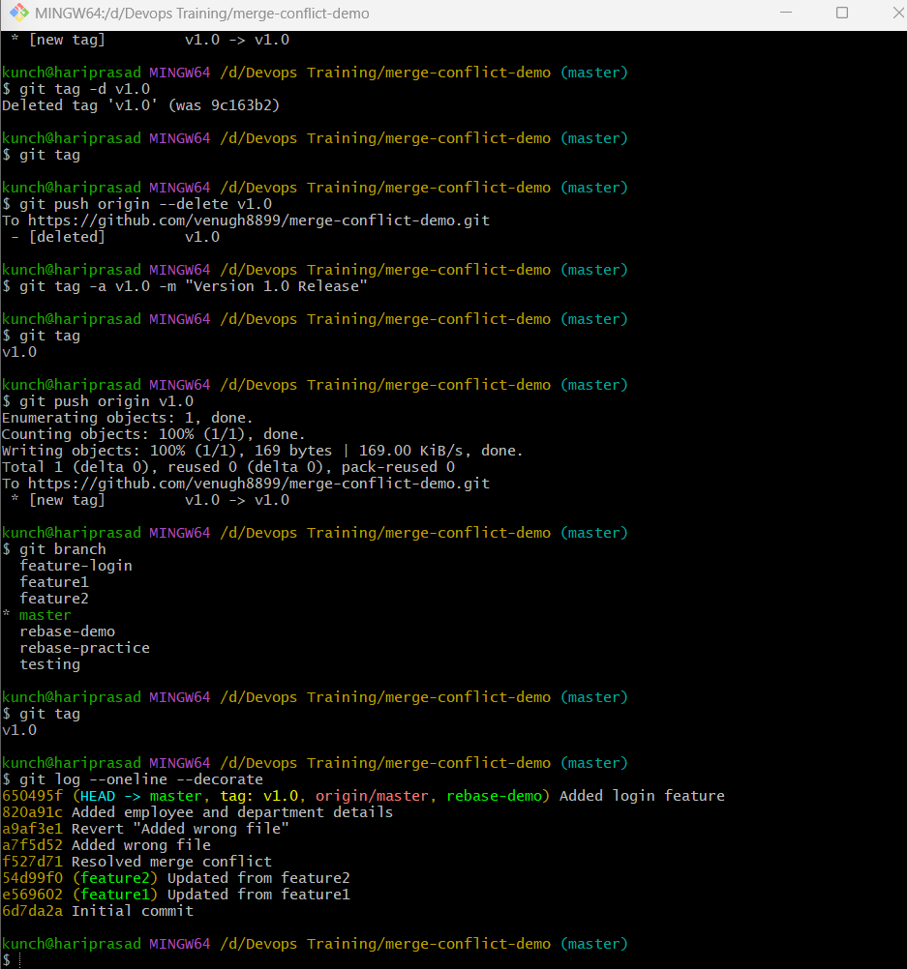

8. Sparse Checkout
Objective
Clone only a specific folder from a repository instead of downloading the entire repository.

What is Sparse Checkout?
Normally, when you clone a repository:
Repository
│
├── src
├── docs
├── scripts
├── terraform
├── kubernetes
├── ansible
└── README.md
Git downloads everything.
With Sparse Checkout, Git downloads only the folders you need, for example:
Repository
│
└── terraform
This saves disk space and time.

Step 1: Go outside your current repository
cd ..
Verify:
pwd
Example:
D:/Devops Training

Step 2: Clone with sparse support
We'll use your GitHub repository.
git clone --filter=blob:none --sparse https://github.com/venugh8899/merge-conflict-demo.git sparse-demo
Explanation:
- --filter=blob:none → Don't download file contents until needed.
- --sparse → Enable sparse checkout.
- sparse-demo → Local directory name.

Step 3: Enter the cloned repository
cd sparse-demo
Check:
git branch
Expected:
* master

Step 4: Initialize sparse checkout
git sparse-checkout init

Step 5: See the repository contents
ls
If your repository has only files in the root (like demo.txt, employee.txt, etc.), you'll still see those because sparse checkout mainly shines when there are multiple directories.

Step 6: Try checking out only a folder
Suppose your repository had this structure:
merge-conflict-demo
│
├── docs
├── src
├── terraform
└── ansible
You could run:
git sparse-checkout set terraform
Only the terraform folder would appear in your working tree.
If you wanted multiple folders:
git sparse-checkout set terraform ansible
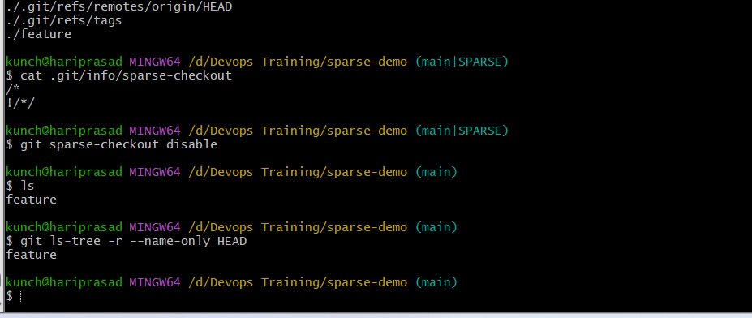

9. Reset vs Revert
Objective
Understand the difference between:
- git reset --hard → Removes commits from history (local history rewrite).
- git revert → Creates a new commit that undoes an earlier commit (safe for shared repositories).
We'll demonstrate both.

Part A – git reset --hard
Step 1: Create a new branch
We'll use a separate branch so your master branch stays clean.
git checkout -b reset-demo

Step 2: Create Commit 1
echo "Version 1" > reset.txt
git add reset.txt
git commit -m "Version 1"

Step 3: Create Commit 2
echo "Version 2" >> reset.txt
git add reset.txt
git commit -m "Version 2"

Step 4: View the history
git log --oneline
Example:
a2b3c4d Version 2
e5f6g7h Version 1

Step 5: Reset to the previous commit
git reset --hard HEAD~1
Expected:
HEAD is now at e5f6g7h Version 1
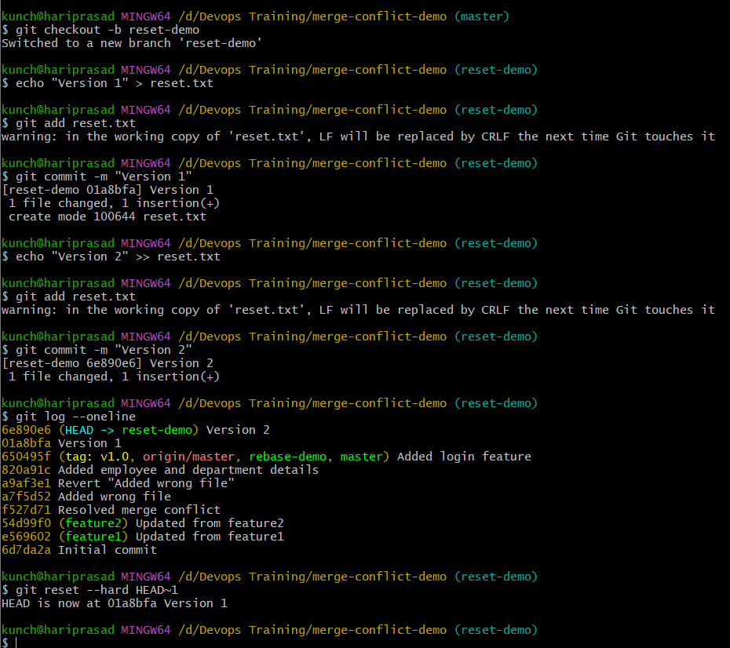

Step 6: Verify
git log --oneline
Now you'll see only:
e5f6g7h Version 1
Also check the file:
cat reset.txt
Output:
Version 1
The Version 2 commit has disappeared from the branch history.
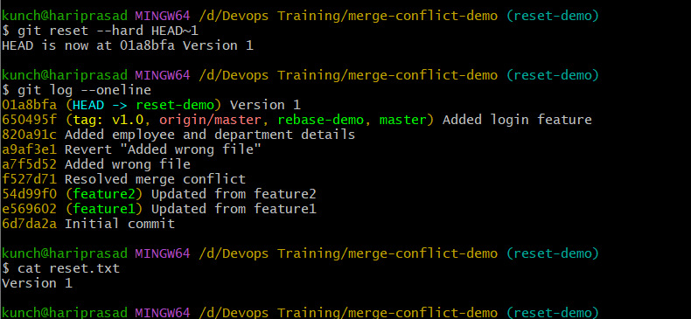

Part B – git revert
Step 7: Recreate Version 2
echo "Version 2" >> reset.txt
git add reset.txt
git commit -m "Version 2"
History:
Version 2
Version 1

Step 8: Revert the latest commit
git revert HEAD
Git opens the editor.
Keep the default message:
Revert "Version 2"
Save and exit.

Step 9: Verify the history
git log --oneline
Now you'll see:
Revert "Version 2"
Version 2
Version 1
Notice:
- Version 2 is still in history.
- A new commit has been added to undo it.

Step 10: Verify the file
cat reset.txt
Output:
Version 1

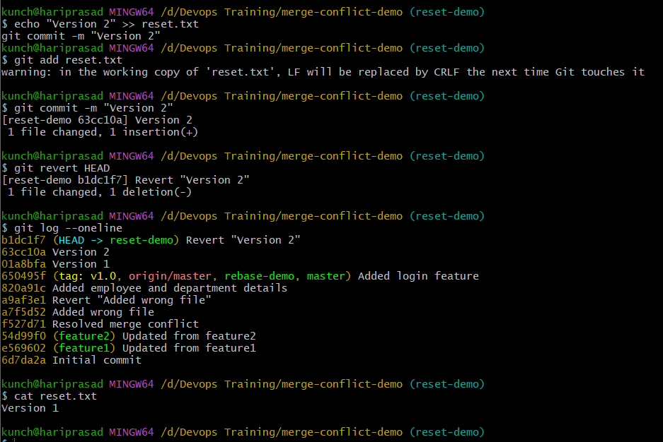

10. Detached HEAD
Normally:
master
│
▼
Commit A → Commit B → Commit C (HEAD)
HEAD points to the master branch.
When you checkout a commit directly:
git checkout <commit-id>
it becomes:
master
│
▼
Commit A → Commit B → Commit C

HEAD
│
▼
Commit B
Now HEAD points directly to a commit, not to a branch.

Step 1: Go to your practice repository
cd ../merge-conflict-demo
Switch to master:
git checkout master

Step 2: View commit history
git log --oneline
Example:
650495f Added login feature
820a91c Added employee and department details
a9af3e1 Revert "Added wrong file"
Choose an older commit.
For example:
820a91c

Step 3: Checkout that commit
git checkout 820a91c
Git displays something similar to:
Note: switching to '820a91c'.

You are in 'detached HEAD' state.

HEAD is now at 820a91c Added employee and department details
This is exactly what we want.

Step 4: Verify
git status
Expected:
HEAD detached at 820a91c
nothing to commit, working tree clean
Also verify:
git branch
Output:
* (HEAD detached at 820a91c)
master
feature1
feature2
...
Notice that you're not on any branch.
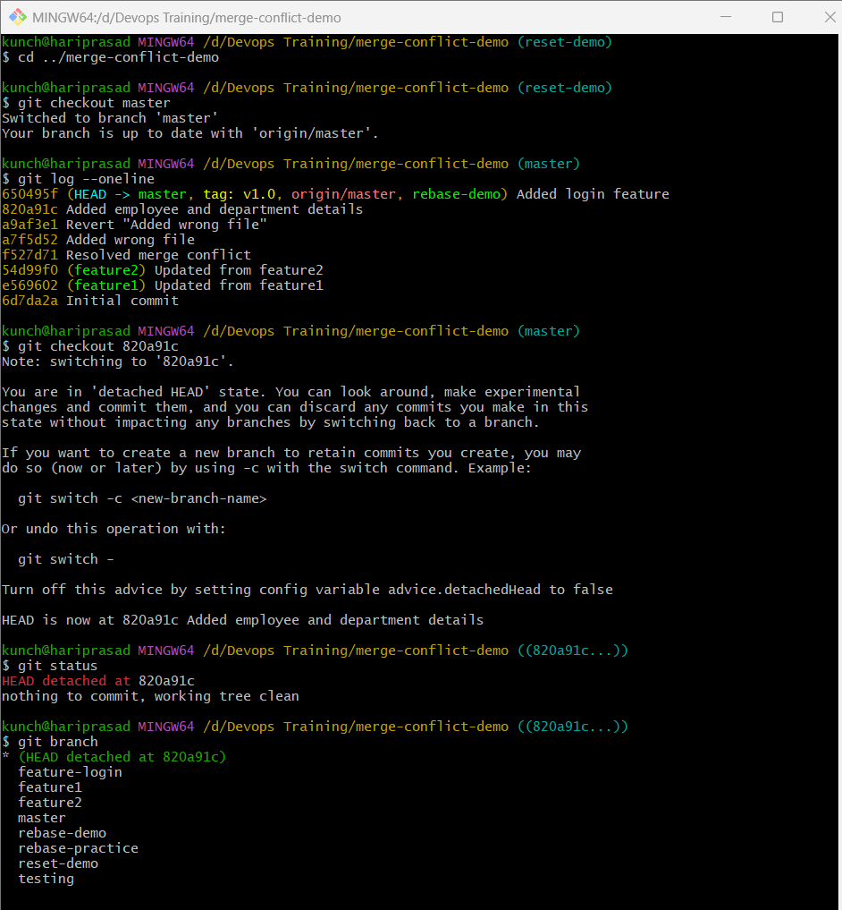

Step 5: Create a file
echo "Detached HEAD Practice" > detached.txt
Stage it:
git add detached.txt
Commit it:
git commit -m "Commit from detached HEAD"
Expected:
[detached HEAD xxxxxxx] Commit from detached HEAD

Step 6: Verify the history
git log --oneline -3
Example:
abc1234 Commit from detached HEAD
820a91c Added employee and department details
This commit exists, but no branch points to it.

Step 7: Create a branch to save the commit
git checkout -b detached-demo
Expected:
Switched to a new branch 'detached-demo'

Step 8: Verify
git branch
Output:
* detached-demo
master
feature1
feature2
...
Now your new commit is safely attached to the detached-demo branch.

Step 9: Push the branch (optional)
git push -u origin detached-demo

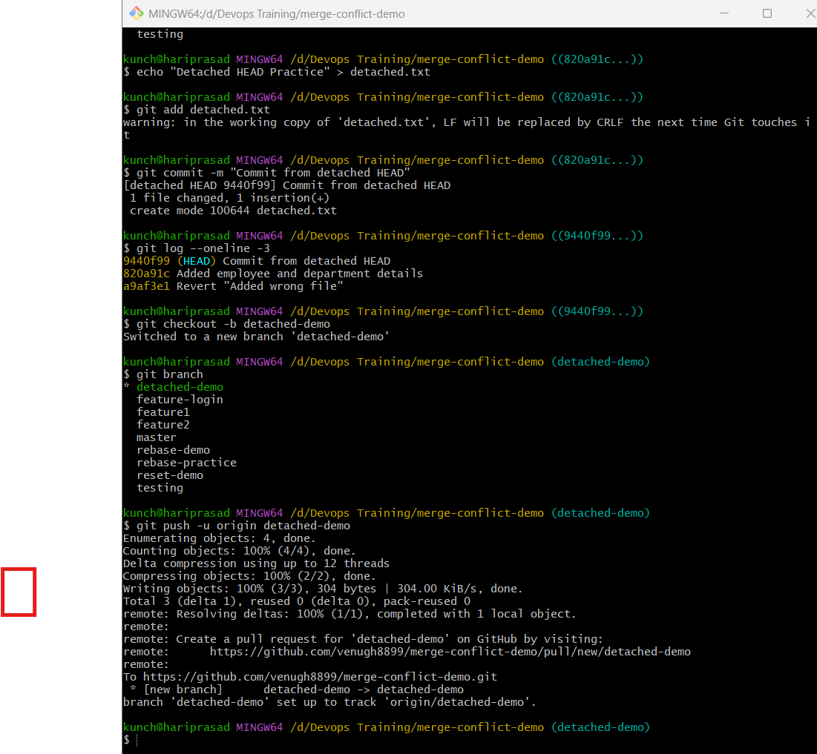

11. Git Hooks Challenge
Objective
Create a hook that:
- ✅ Accepts:
JIRA-101 Added login page
- ❌ Rejects:
Added login page

What are Git Hooks?
Git hooks are scripts that Git automatically runs at certain points, such as:
- Before a commit
- After a commit
- Before a push
- When checking out a branch
They are commonly used to:
- Enforce commit message standards
- Run tests
- Check code formatting
- Prevent accidental commits

Step 1: Go to your practice repository
cd ../merge-conflict-demo

Step 2: Go to the hooks directory
cd .git/hooks
List the files:
ls
You'll see example hook files like:
applypatch-msg.sample
commit-msg.sample
pre-commit.sample
pre-push.sample
...

Step 3: Create a commit-msg hook
Using Nano:
nano commit-msg
Paste the following script:
#!/bin/sh

MESSAGE=$(cat "$1")

echo "$MESSAGE" | grep -q "^JIRA-[0-9]\+"

if [ $? -ne 0 ]
then
echo "ERROR: Commit message must start with JIRA-XXX"
exit 1
fi

exit 0
Save the file:
- Ctrl + O
- Enter
- Ctrl + X

Step 4: Make the hook executable
In Git Bash:
chmod +x commit-msg
Verify:
ls -l commit-msg
Expected:
-rwxr-xr-x

Step 5: Test with an invalid commit message
Create a test file:
echo "Testing hooks" > hooks.txt
git add hooks.txt
Now try:
git commit -m "Added hooks file"
Expected output:
ERROR: Commit message must start with JIRA-XXX
The commit will be rejected.

Step 6: Test with a valid commit message
git commit -m "JIRA-101 Added hooks file"
Expected:
[master xxxxxxx] JIRA-101 Added hooks file
The commit succeeds.

Step 7: Verify
git log --oneline -1
Output:
abc1234 JIRA-101 Added hooks file
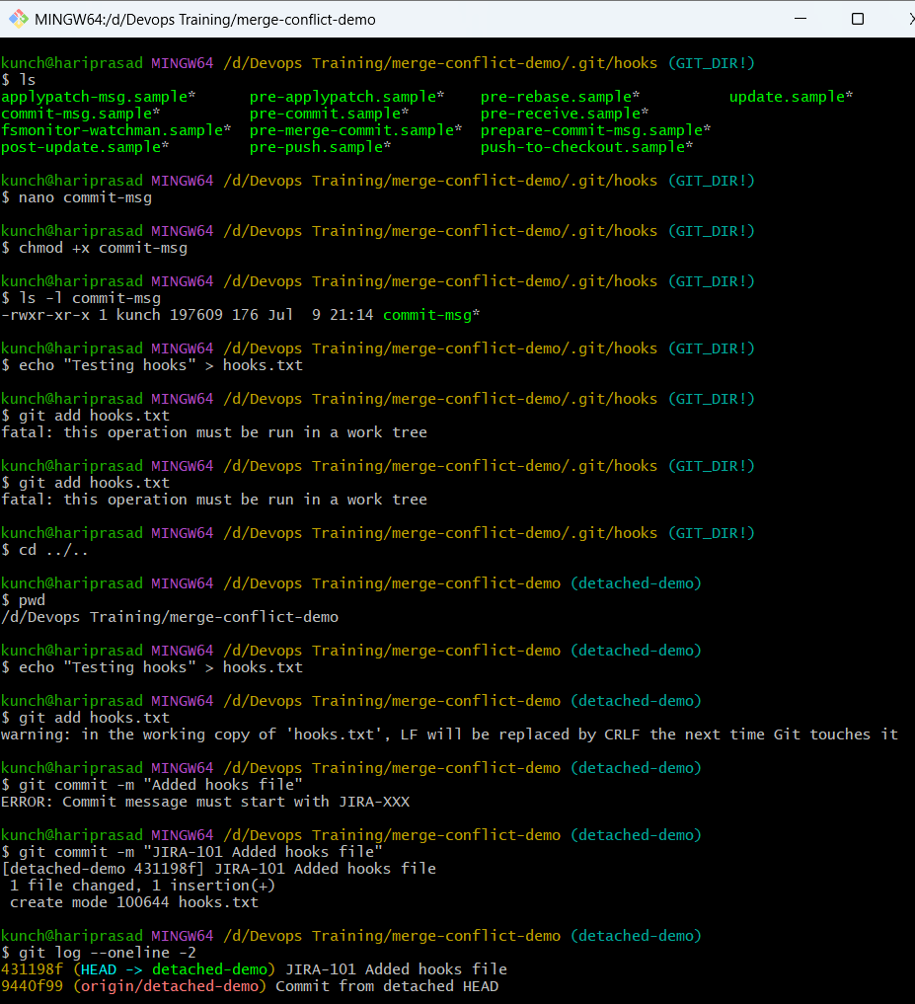

12. Squash Merge vs Rebase Merge
Objective
Understand the difference between:
- Squash Merge
- Rebase Merge
and see how each affects Git history.

Repository Setup
Go to your practice repository:
cd /d/"Devops Training"/merge-conflict-demo
git checkout master
Create a new branch:
git checkout -b feature-ui

Step 1: Create three commits
Commit 1
echo "HTML" > ui.txt
git add ui.txt
git commit -m "JIRA-201 Added HTML"
Commit 2
echo "CSS" >> ui.txt
git add ui.txt
git commit -m "JIRA-202 Added CSS"
Commit 3
echo "JavaScript" >> ui.txt
git add ui.txt
git commit -m "JIRA-203 Added JavaScript"
Verify:
git log --oneline
Example:
abc123 JIRA-203 Added JavaScript
def456 JIRA-202 Added CSS
ghi789 JIRA-201 Added HTML

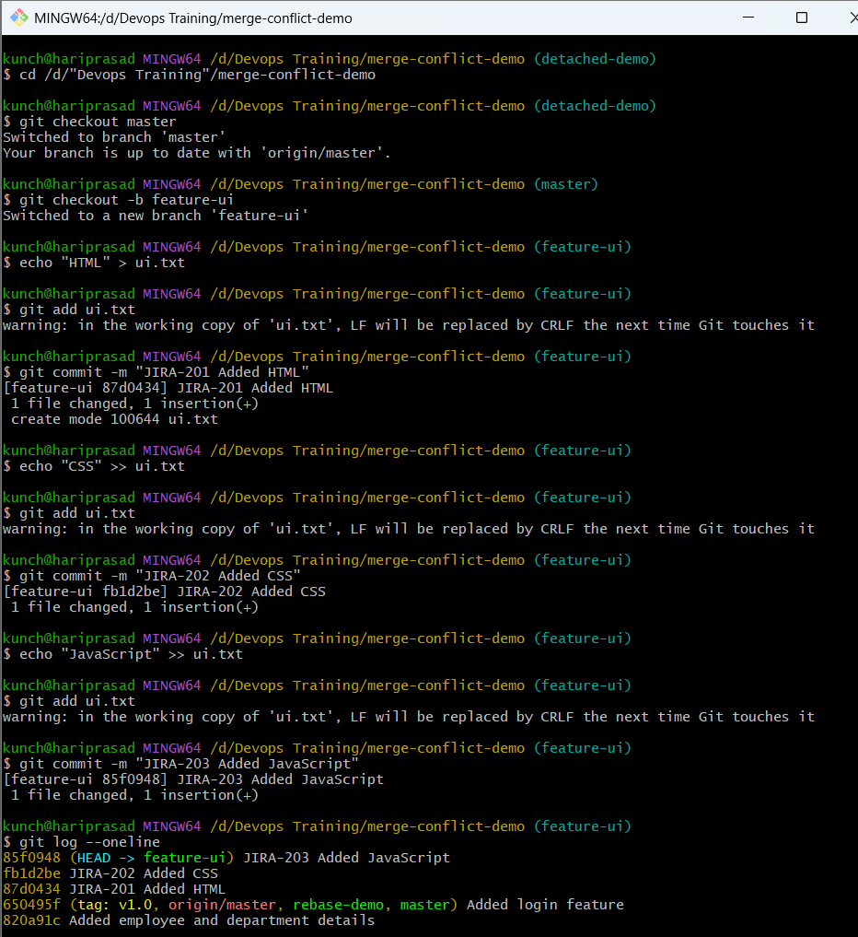

Part A – Squash Merge
Switch back to master:
git checkout master
Merge using squash:
git merge --squash feature-ui
Git stages all the changes but does not create a merge commit.
Create one commit:
git commit -m "JIRA-204 Squash merged feature-ui"

Verify the history
git log --oneline --graph
Example:
* JIRA-204 Squash merged feature-ui
* Previous commits...
Notice:
- The three commits from feature-ui are not on master.
- Only one new commit represents all the changes.

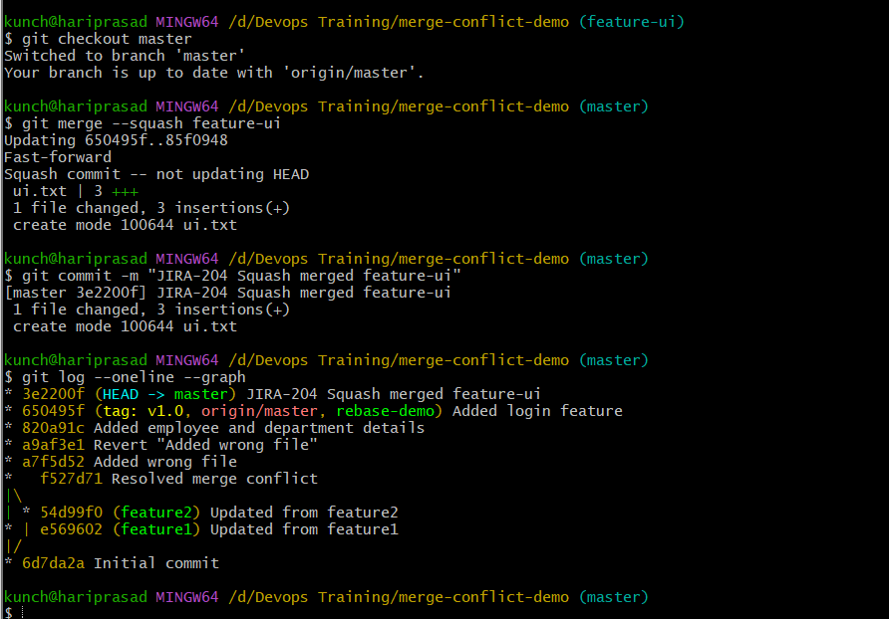

Part B – Rebase Merge
Create another branch:
git checkout -b feature-api

Create two commits
echo "API v1" > api.txt
git add api.txt
git commit -m "JIRA-301 Added API"
echo "API v2" >> api.txt
git add api.txt
git commit -m "JIRA-302 Updated API"

Rebase onto master
git checkout feature-api
git rebase master
If there are conflicts, resolve them and continue:
git add .
git rebase --continue

Merge into master
git checkout master
git merge feature-api
Because the branch was rebased, Git usually performs a fast-forward merge.

Verify
git log --oneline --graph --all
Example:
* JIRA-302 Updated API
* JIRA-301 Added API
* JIRA-204 Squash merged feature-ui
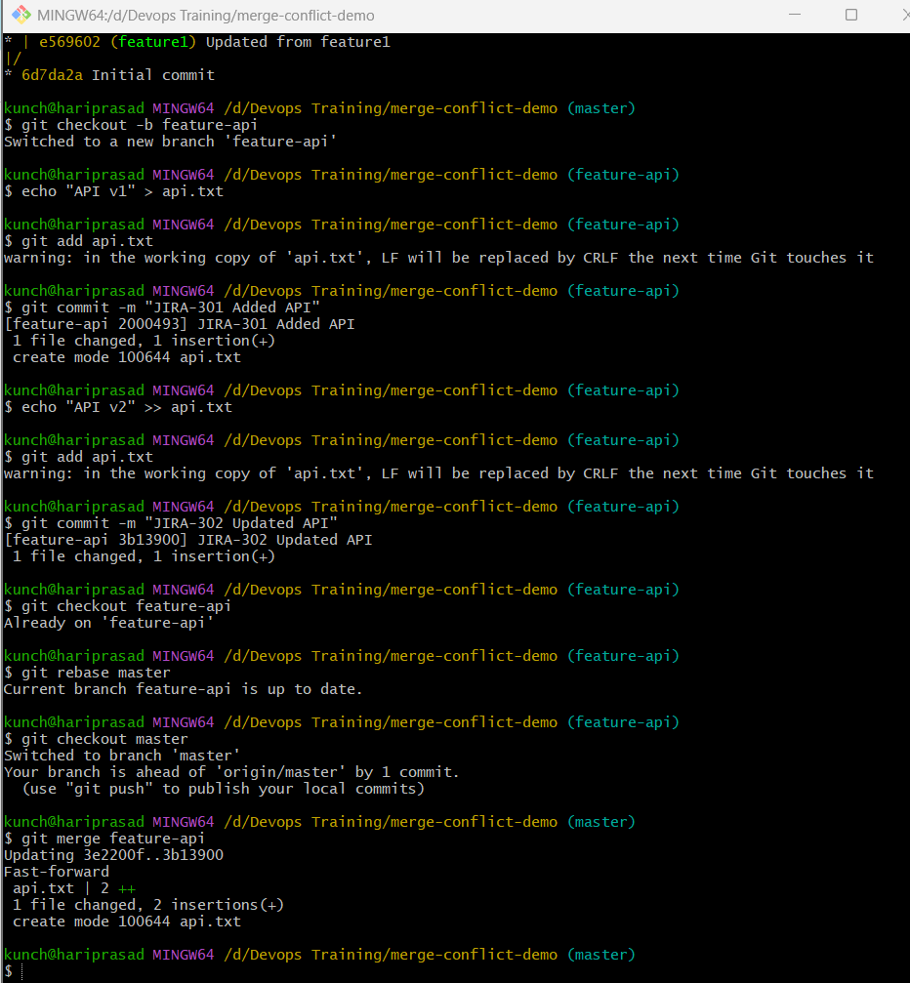
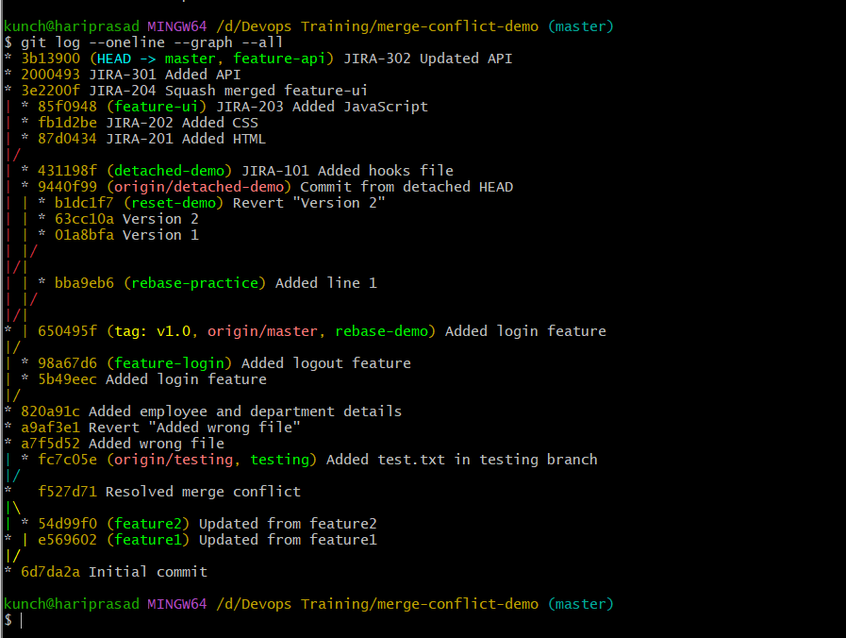

13. Fork & Pull Request Workflow
Objective
Learn how to:
- Fork another repository.
- Clone your fork.
- Create a new branch.
- Make changes.
- Push the branch.
- Create a Pull Request (PR) to the original repository.

Real-World Workflow
Original Repository (upstream)
│
▼
Fork
│
▼
Clone your fork
│
▼
Create feature branch
│
▼
Make changes
│
▼
Push branch
│
▼
Create Pull Request

Step 1: Choose a Repository to Fork
Choose any public GitHub repository that allows forks. For example, you can use:
- A practice repository from a friend.
- A training repository.
- A public sample repository.
Click the Fork button on GitHub.
After forking:
Original Repo
│
▼
Your Fork
Example:
Original:
username/git-demo

Fork:
venugh8899/git-demo

Step 2: Clone Your Fork
Copy the URL of your fork.
Example:
git clone https://github.com/<your-github-username>/<repository-name>.git
For example, if your fork is named git-demo:
git clone https://github.com/venugh8899/git-demo.git
Then:
cd git-demo

Step 3: Add the Original Repository as upstream
Check existing remotes:
git remote -v
Output:
origin https://github.com/venugh8899/git-demo.git
Add the original repository:
git remote add upstream https://github.com/original-owner/git-demo.git
Verify:
git remote -v
Expected:
origin https://github.com/venugh8899/git-demo.git
upstream https://github.com/original-owner/git-demo.git

Step 4: Create a Feature Branch
git checkout -b feature-readme

Step 5: Make a Change
Example:
echo "Fork Workflow Practice" >> README.md
Stage and commit:
git add README.md
git commit -m "JIRA-401 Updated README"

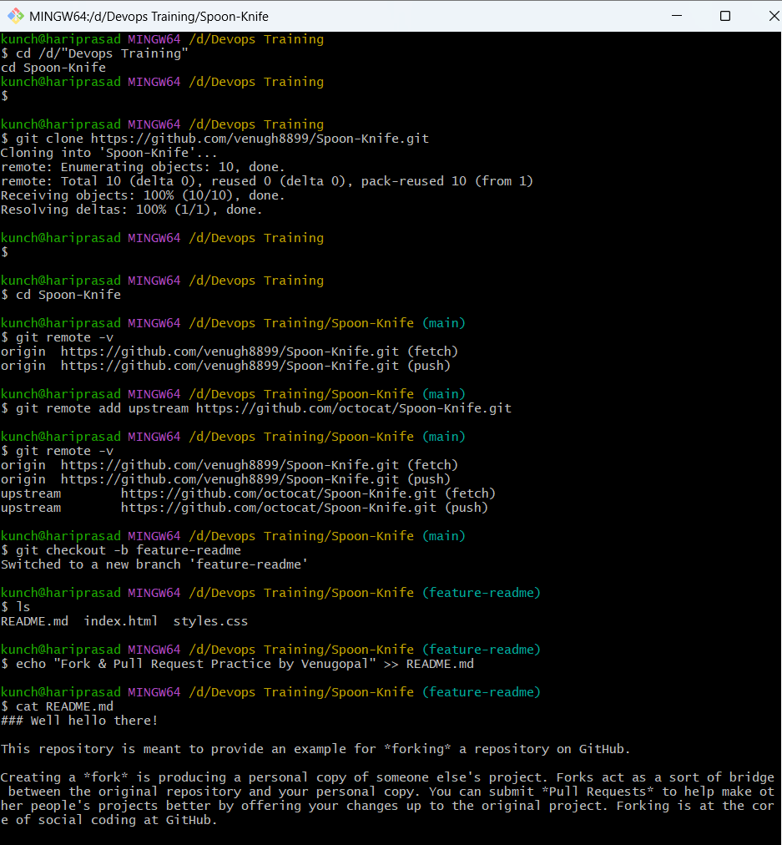
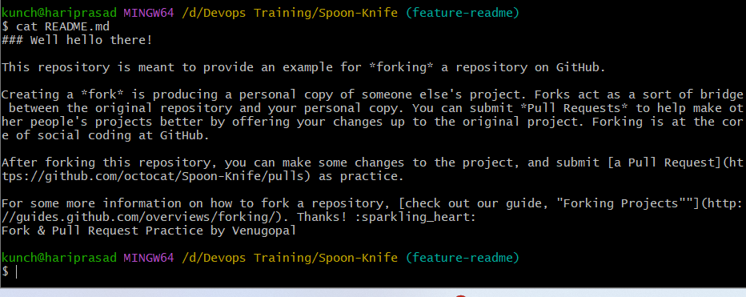

Step 6: Push the Branch
git push -u origin feature-readme
This pushes the branch to your fork.

Step 7: Create a Pull Request
On GitHub:
- Open your fork.
- You'll see a banner like:
Compare & pull request
- Click it.
If you don't see it:
- Go to the Pull requests tab.
- Click New pull request.
Ensure:
- Base repository = Original repository (upstream)
- Base branch = main or master
- Head repository = Your fork
- Compare branch = feature-readme
Example:
Base: original-owner/git-demo:main

←

Compare: venugh8899/git-demo:feature-readme

Step 8: Submit the Pull Request
Title:
JIRA-401 Updated README
Description:
Added README updates for Git practice.
Click:
Create Pull Request
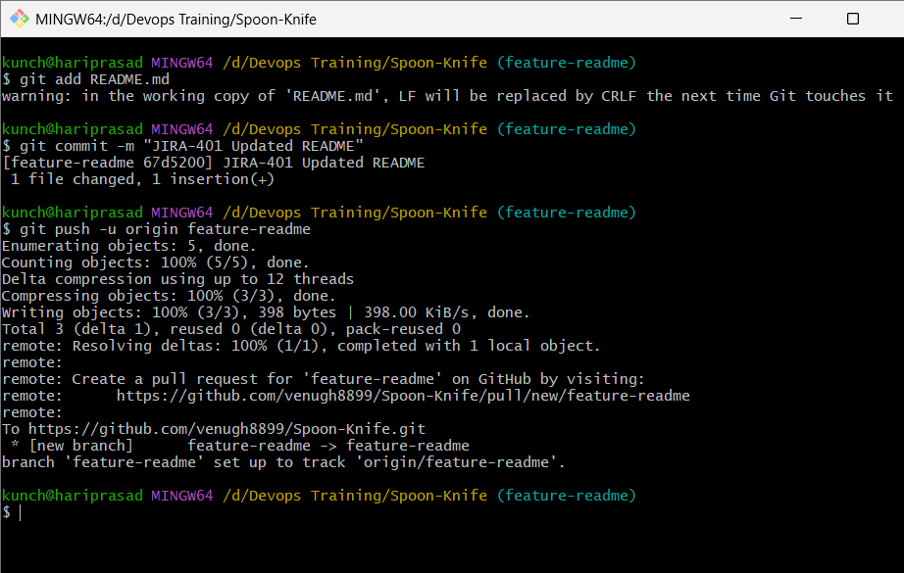

Step 9: Keep Your Fork Updated
Fetch the latest changes from the original repository:
git fetch upstream
Switch to your main branch:
git checkout main
Merge updates:
git merge upstream/main
Push your updated main branch to your fork:
git push origin main

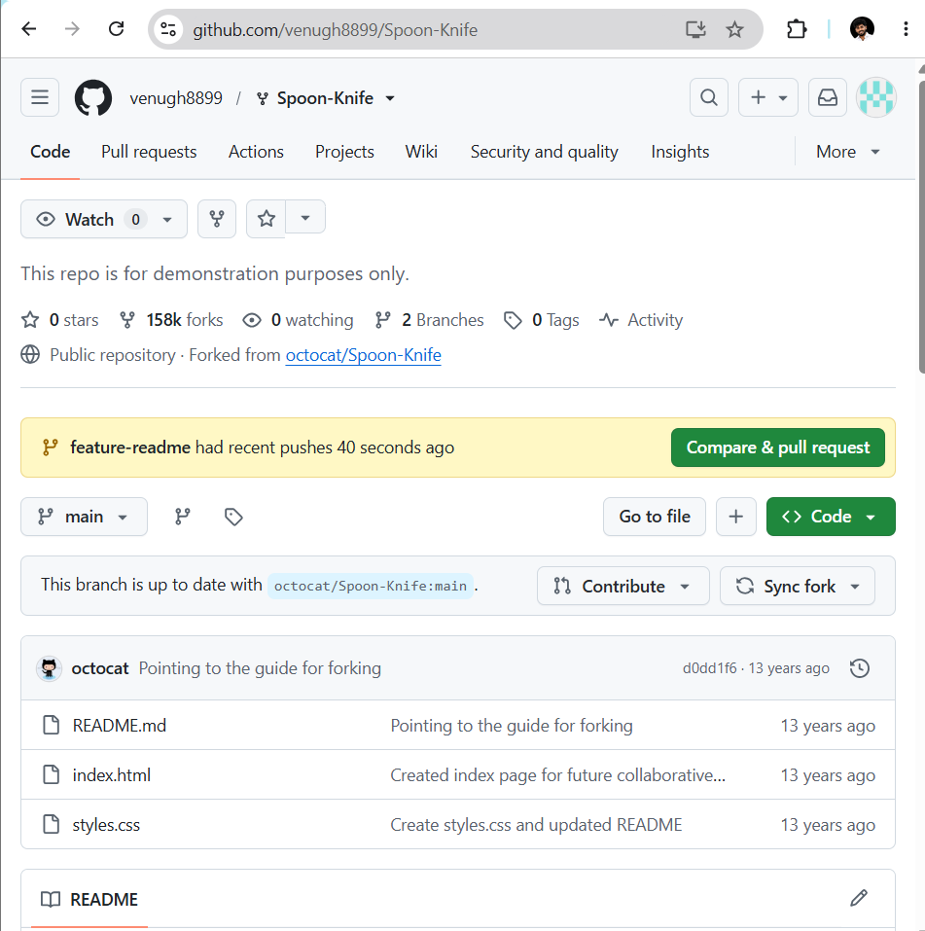

14. Recover Lost Commit
Objective
Learn how to:
- Create a commit.
- Accidentally remove it using git reset --hard.
- Recover it using git reflog.
This is one of the most important Git recovery techniques and a common interview question.

Step 1: Go to your repository
cd /d/"Devops Training"/merge-conflict-demo
Switch to a new branch:
git checkout -b reflog-demo

Step 2: Create a file
echo "Git Reflog Demo" > reflog.txt
Stage it:
git add reflog.txt
Commit it:
git commit -m "JIRA-501 Added reflog demo file"
Expected:
[reflog-demo abc1234] JIRA-501 Added reflog demo file

Step 3: Verify the commit
git log --oneline -3
Example:
abc1234 JIRA-501 Added reflog demo file
650495f Added login feature
820a91c Added employee and department details

Step 4: Remove the latest commit
git reset --hard HEAD~1
Expected:
HEAD is now at 650495f Added login feature
Verify:
git log --oneline
The commit is gone.
Also check:
ls
reflog.txt should no longer be present.
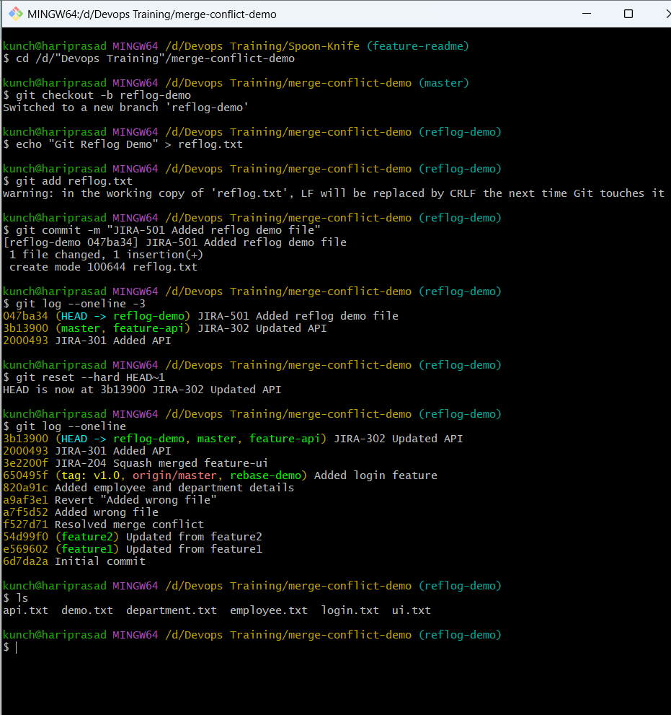

Step 5: Recover the lost commit
Run:
git reflog
Example:
650495f HEAD@{0}: reset: moving to HEAD~1
abc1234 HEAD@{1}: commit: JIRA-501 Added reflog demo file
650495f HEAD@{2}: checkout: moving from master to reflog-demo
Notice the commit hash:
abc1234
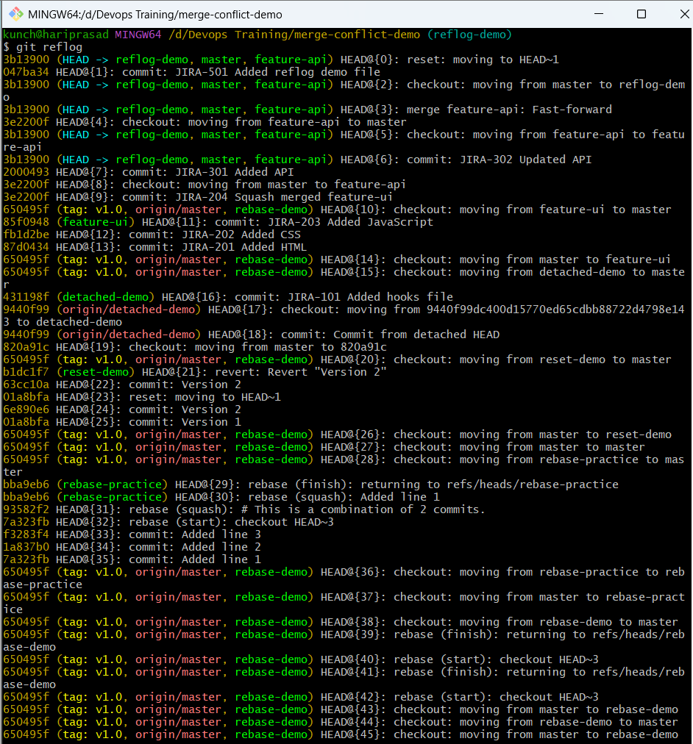

Step 6: Restore the commit
Using the commit hash:
git reset --hard abc1234
(or replace abc1234 with the hash from your output)
Expected:
HEAD is now at abc1234 JIRA-501 Added reflog demo file

Step 7: Verify
git log --oneline -3
You'll see:
abc1234 JIRA-501 Added reflog demo file
650495f Added login feature
820a91c Added employee and department details
Check the file:
ls
You should see:
reflog.txt
Display its contents:
cat reflog.txt
Output:
Git Reflog Demo
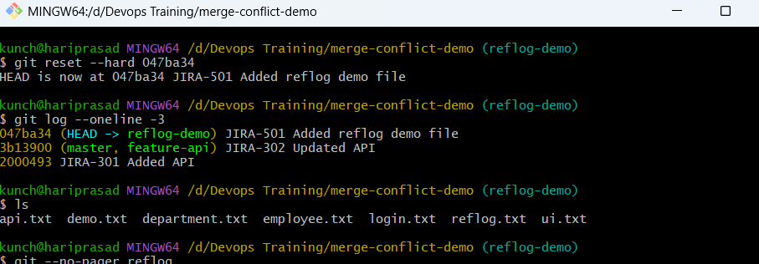
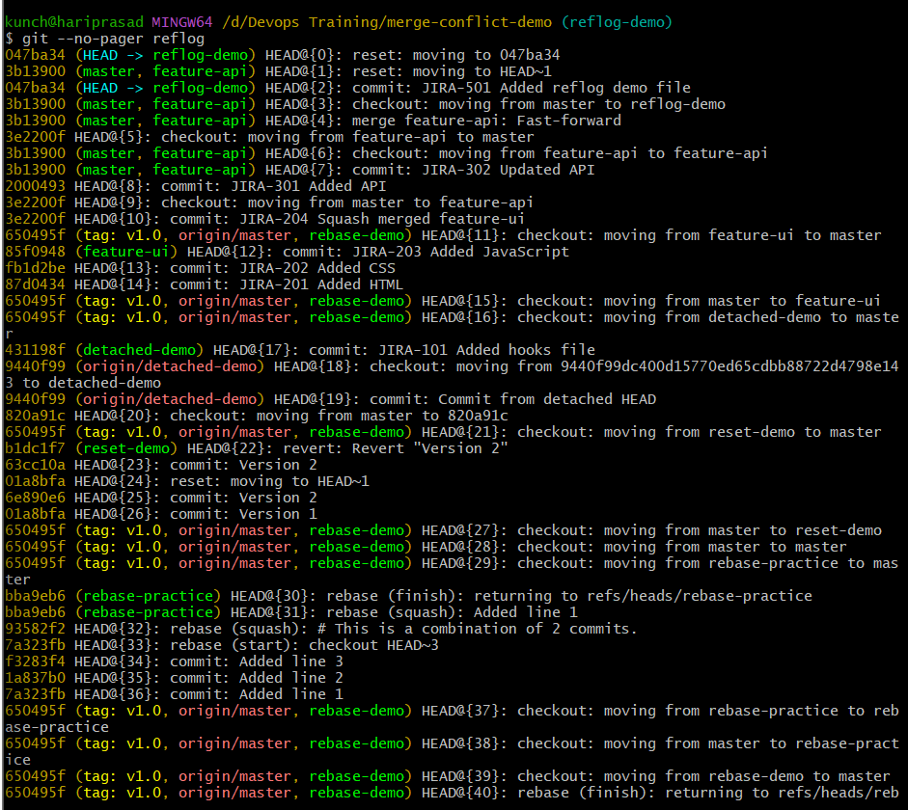
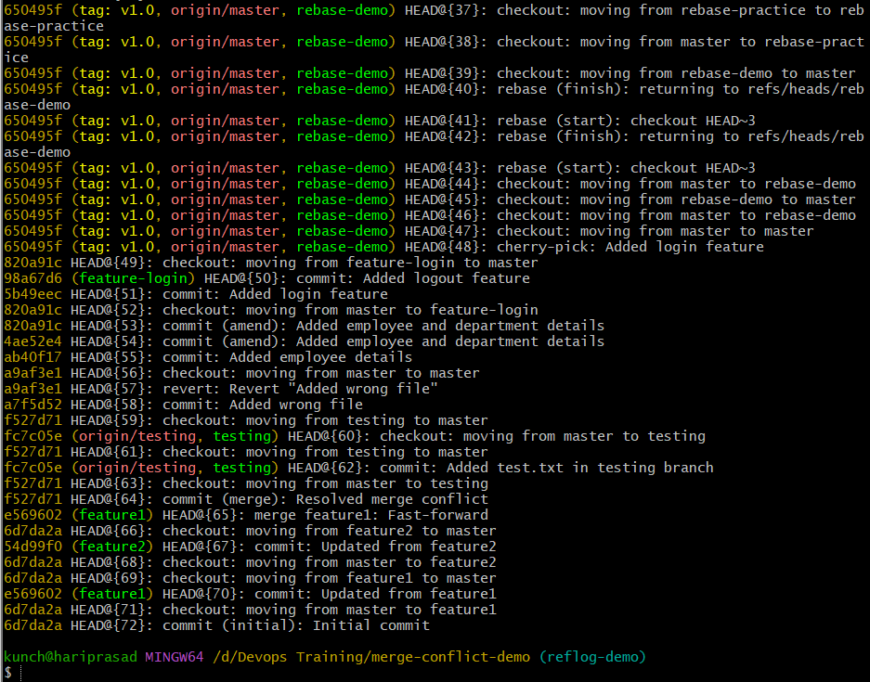

Git Commands Covered
- git merge
- git cherry-pick
- git commit --amend
- git reflog
- git reset --hard
- git revert
- git rebase -i
- git tag
- git sparse-checkout
- git checkout
- git hooks
- git merge --squash
- git rebase
- git push
- git pull
- git branch
- git log

